Query: hospitals

1.findings

<title>

Bharati Hospital Dumka, Jharkhand

**206.189.129.56**

<http://206.189.129.56:3001/>

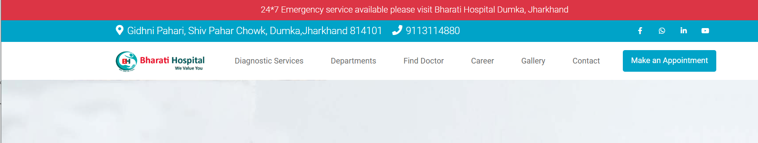

2. Findings

<title>

# **Accord Hospital**

# **Smart Hospital**

<http://115.241.53.196:9001>

**115.241.53.196**

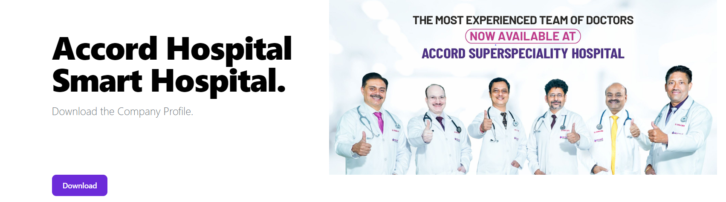

3. Findings

<title>

**Goutam Neuro Care**

**65.2.65.231**

**http://65.2.65.231:9091/**

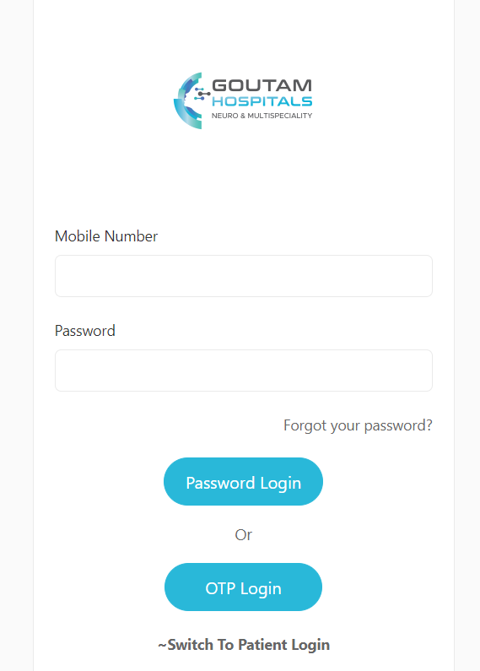

4.findings

<title>



ARJO Rental Service App

Hospitals login

**202.149.207.58**

<http://202.149.207.58:9001/#/login>

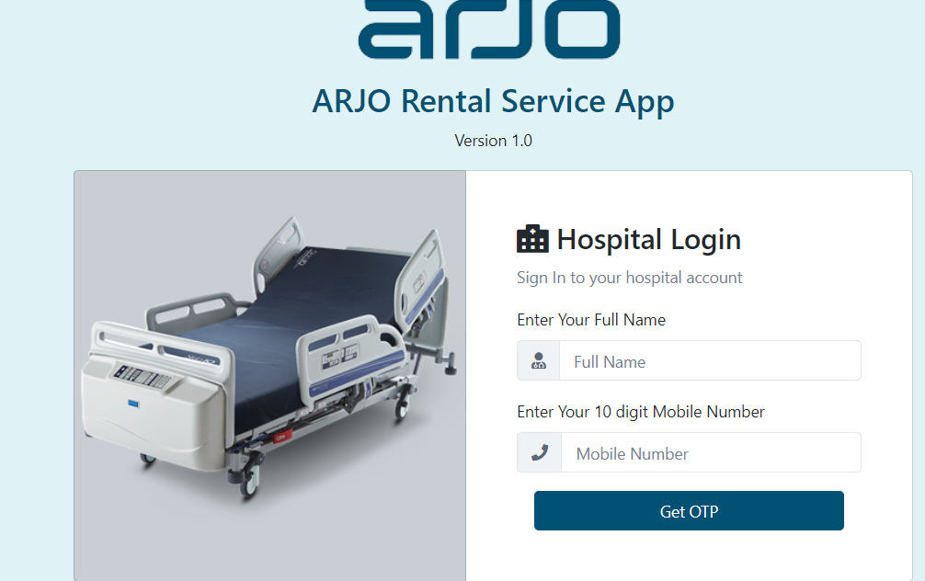

5. Findings

<title>

<title>Book Appointment or Consult with the Top Doctors Online | Apollo Hospitals

<https://www.askapollo.com/>

**20.40.0.168**